**LECTURE NOTES**

**UNIT I (Part I)**

**Unit 1: Introduction**

|  |
| --- |
| **INTRODUCTION**  Feature of Java, JVM, JRE, setting Class path |
| Lexical Elements, Types and Literals, Variables, Array Variables, Naming |
| Operators, Expressions, Member Access, Precedence, Associativity |

# 1.0 INTRODUCTION

Java is a **programming language** and a **platform**.

**Platform** Any hardware or software environment in which a program runs, known as a platform. Since Java has its own Runtime Environment (JRE) and API, it is called platform.

According to Sun, 3 billion devices run java. There are many devices where java is currently used. Some of them are as follows:

1. Desktop Applications such as acrobat reader, media player, antivirus etc.
2. Web Applications such as irctc.co.in, javatpoint.com etc.
3. Enterprise Applications such as banking applications.
4. Mobile
5. Embedded System
6. Smart Card
7. Robotics
8. Games etc.

# 1.1. TYPES OF JAVA APPLICATIONS

There are mainly 4 type of applications that can be created using java:

**1) Standalone Application**

It is also known as desktop application or window-based application. An application that we need to install on every machine such as media player, antivirus etc. AWT and Swing are used in java for creating standalone applications.

**2) Web Application**

An application that runs on the server side and creates dynamic page, is called web application. Currently, servlet, jsp, struts, jsf etc. technologies are used for creating web applications in java.

**3) Enterprise Application**

An application that is distributed in nature, such as banking applications etc. It has the advantage of high level security, load balancing and clustering. In java, EJB is used for creating enterprise applications.

**4) Mobile Application**

An application that is created for mobile devices. Currently Android and Java ME are used for creating mobile applications.

# 1.2. History of Java

**Java history** is interesting to know. The history of java starts from Green Team. Java team members (also known as **Green Team**), initiated a revolutionary task to develop a language for digital devices such as set-top boxes, televisions etc.

For the green team members, it was an advance concept at that time. But, it was suited for internet programming. Later, Java technology as incorporated by Netscape.

Currently, Java is used in internet programming, mobile devices, games, e-business solutions etc. There are given the major points that describes the history of java.

1) **James Gosling**, **Mike Sheridan**, and **Patrick Naughton** initiated the Java language project in June 1991. The small team of sun engineers called **Green Team**.

2) Originally designed for small, embedded systems in electronic appliances like set-top boxes.

3) Firstly, it was called **"Greentalk"** by James Gosling and file extension was .gt.

4) After that, it was called **Oak** and was developed as a part of the Green project.

5) **Why Oak?** Oak is a symbol of strength and choosen as a national tree of many countries like U.S.A., France, Germany, Romania etc.

6) In 1995, Oak was renamed as **"Java"** because it was already a trademark by Oak Technologies.

7) **Why they choosed java name for java language?** The team gathered to choose a new name. The suggested words were "dynamic", "revolutionary", "Silk", "jolt", "DNA" etc. They wanted something that reflected the essence of the technology: revolutionary, dynamic, lively, cool, unique, and easy to spell and fun to say.

According to James Gosling "Java was one of the top choices along with **Silk**". Since java was so unique, most of the team members preferred java.

8) Java is an island of Indonesia where first coffee was produced (called java coffee).

9) Notice that Java is just a name not an acronym.

10) Originally developed by James Gosling at Sun Microsystems (which is now a subsidiary of Oracle Corporation) and released in 1995.

11) In 1995, Time magazine called **Java one of the Ten Best Products of 1995**.

12) JDK 1.0 released in(January 23, 1996).

There are many java versions that has been released.

1. JDK Alpha and Beta (1995)
2. JDK 1.0 (23rd Jan, 1996)
3. JDK 1.1 (19th Feb, 1997)
4. J2SE 1.2 (8th Dec, 1998)
5. J2SE 1.3 (8th May, 2000)
6. J2SE 1.4 (6th Feb, 2002)
7. J2SE 5.0 (30th Sep, 2004)
8. Java SE 6 (11th Dec, 2006)
9. Java SE 7 (28th July, 2011)

# 1.3. Features of Java

There is given many features of java. They are also known as java buzzwords. The Java Features given below are simple and easy to understand.

1. Simple
2. Object-Oriented
3. Platform independent
4. Secured
5. Robust
6. Architecture neutral
7. Portable
8. Dynamic
9. Interpreted
10. High Performance
11. Multithreaded
12. Distributed

### Simple

|  |
| --- |
| According to Sun, Java language is simple because: |
| syntax is based on C++ (so easier for programmers to learn it after C++). |
| removed many confusing and/or rarely-used features e.g., explicit pointers, operator overloading etc. |
| No need to remove unreferenced objects because there is Automatic Garbage Collection in java. |

### Object-oriented

|  |
| --- |
| Object-oriented means we organize our software as a combination of different types of objects that incorporates both data and behaviour. |
| Object-oriented programming(OOPs) is a methodology that simplify software development and maintenance by providing some rules. |
| Basic concepts of OOPs are: |
| 1. Object 2. Class 3. Inheritance 4. Polymorphism 5. Abstraction 6. Encapsulation |

### Platform Independent

|  |
| --- |
| A platform is the hardware or software environment in which a program runs. There are two types of platforms software-based and hardware-based. Java provides software-based platform. The Java platform differs from most other platforms in the sense that it's a software-based platform that runs on top of other hardware-based platforms.It has two components:   1. Runtime Environment 2. API(Application Programming Interface) |

|  |
| --- |
| java is platform independent  Java code can be run on multiple platforms e.g.Windows,Linux,Sun Solaris,Mac/OS etc. Java code is compiled by the compiler and converted into bytecode.This bytecode is a platform independent code because it can be run on multiple platforms i.e. Write Once and Run Anywhere(WORA). |

### Secured

|  |
| --- |
| Java is secured because: |
| * No explicit pointer * Programs run inside virtual machine sandbox. |

|  |  |
| --- | --- |
| how java is secured | how java is secured |

|  |
| --- |
| * **Classloader-** adds security by separating the package for the classes of the local file system from those that are imported from network sources. * **Bytecode Verifier-** checks the code fragments for illegal code that can violate access right to objects. * **Security Manager-** determines what resources a class can access such as reading and writing to the local disk. |
| These security are provided by java language. Some security can also be provided by application developer through SSL,JAAS,cryptography etc. |

### Robust

|  |
| --- |
| Robust simply means strong. Java uses strong memory management. There are lack of pointers that avoids security problem. There is automatic garbage collection in java. There is exception handling and type checking mechanism in java. All these points makes java robust. |

### Architecture-neutral

|  |
| --- |
| There is no implementation dependent features e.g. size of primitive types is set. |

### Portable

|  |
| --- |
| We may carry the java bytecode to any platform. |

### High-performance

|  |
| --- |
| Java is faster than traditional interpretation since byte code is "close" to native code still somewhat slower than a compiled language (e.g., C++) |

### Distributed

|  |
| --- |
| We can create distributed applications in java. RMI and EJB are used for creating distributed applications. We may access files by calling the methods from any machine on the internet. |

### Multi-threaded

A thread is like a separate program, executing concurrently. We can write Java programs that deal with many tasks at once by defining multiple threads. The main advantage of multi-threading is that it shares the same memory. Threads are important for multi-media, Web applications etc.

# 1.4. Simple Program of Java

In this page, we will learn how to write the hello java program. We can write a simple hello java program easily.

To create a simple java program, you need to create a class that contains main method. Let's understand the requirement first.

### Requirement for Hello Java Example

|  |
| --- |
| For executing any java program, you need to   * install the JDK if you don't have installed it, **[download the JDK](http://www.oracle.com/technetwork/java/javase/downloads/index.html" \t "_blank)** and install it. * set path of the jdk/bin directory. [**http://www.javatpoint.com/how-to-set-path-in-java**](http://www.javatpoint.com/how-to-set-path-in-java) * create the java program * compile and run the java program |

### Creating hello java example

|  |
| --- |
| Let's create the hello java program: |

1. **class** Simple{
2. **public** **static** **void** main(String args[]){
3. System.out.println("Hello Java");
4. }
5. }

|  |  |
| --- | --- |
| save this file as Simple.java | |
| **To compile:** | javac Simple.java | |
| **To execute:** | java Simple | |

**Output:**Hello Java

### Understanding first java program

Let's see what is the meaning of class, public, static, void, main, String[], System.out.println().

* **class** keyword is used to declare a class in java.
* **public** keyword is an access modifier which represents visibility, it means it is visible to all.
* **static** is a keyword, if we declare any method as static, it is known as static method. The core advantage of static method is that there is no need to create object to invoke the static method. The main method is executed by the JVM, so it doesn't require to create object to invoke the main method. So it saves memory.
* **void** is the return type of the method, it means it doesn't return any value.
* **main** represents startup of the program.
* **String[] args** is used for command line argument. We will learn it later.
* **System.out.println()** is used print statement. We will learn about the internal working of System.out.println statement later.

|  |
| --- |
| To write the simple program, open notepad by **start menu -> All Programs -> Accessories -> notepad**and write simple program as displayed below: |
| As displayed in the above diagram, write the simple program of java in notepad and saved it as Simple.java. To compile and run this program, you need to open command prompt by **start menu -> All Programs -> Accessories -> command prompt**. |
| To compile and run the above program, go to your current directory first; my current directory is c:\new . Write here: |

|  |  |
| --- | --- |
| **To compile:** | javac Simple.java |
| **To execute:** | java Simple |

# 1.5. Internal Details of Hello Java Program

In the previous page, we have learned about the first program, how to compile and how to run the first java program. Here, we are going to learn, what happens while compiling and running the java program. Moreover, we will see some question based on the first program.

### What happens at compile time?

|  |
| --- |
| At compile time, java file is compiled by Java Compiler (It does not interact with OS) and converts the java code into bytecode. |
| compilation of simple java program |

### What happens at runtime?

|  |
| --- |
| At runtime, following steps are performed: |
| what happens at runtime when simple java program runs |

|  |
| --- |
| **Classloader:**is the subsystem of JVM that is used to load class files. |
| **Bytecode Verifier:**checks the code fragments for illegal code that can violate access right to objects. |
| **Interpreter:**read bytecode stream then execute the instructions. |

# 1.6. How to set path in Java

The path is required to be set for using tools such as javac, java etc.If you are saving the java source file inside the jdk/bin directory, path is not required to be set because all the tools will be available in the current directory.But If you are having your java file outside the jdk/bin folder, it is necessary to set path of JDK.

There are 2 ways to set java path:

1. temporary
2. permanent

### 1) How to set Temporary Path of JDK in Windows

To set the temporary path of JDK, you need to follow following steps:

* Open command prompt
* copy the path of jdk/bin directory
* write in command prompt: set path=copied\_path

### For Example:

set path=C:\Program Files\Java\jdk1.6.0\_23\bin

Let's see it in the figure given below:

### 2) How to set Permanent Path of JDK in Windows

For setting the permanent path of JDK, you need to follow these steps:

* Go to MyComputer properties -> advanced tab -> environment variables -> new tab of user variable -> write path in variable name -> write path of bin folder in variable value -> ok -> ok -> ok

|  |
| --- |
|  |
|  |
|  |
| 1.7. Difference between JDK, JRE and JVM Understanding the difference between JDK, JRE and JVM is important in Java. We are having brief overview of JVM here.  If you want to get the detailed knowledge of Java Virtural Machine, move to the next page. Firstly, let's see the basic differences between the JDK, JRE and JVM. | |
| 1.7.1. JVM  |  | | --- | | JVM (Java Virtual Machine) is an abstract machine. It is a specification that provides runtime environment in which java bytecode can be executed. | | JVMs are available for many hardware and software platforms. JVM, JRE and JDK are platform dependent because configuration of each OS differs. But, Java is platform independent. | | The JVM performs following main tasks:   * Loads code * Verifies code * Executes code * Provides runtime environment | |  |  1.7.2. JRE  |  | | --- | | JRE is an acronym for Java Runtime Environment.It is used to provide runtime environment.It is the implementation of JVM.It physically exists.It contains set of libraries + other files that JVM uses at runtime. | | Implementation of JVMs are also actively released by other companies besides Sun Micro Systems. | | jre |  1.7.3. JDK  |  | | --- | | JDK is an acronym for Java Development Kit.It physically exists.It contains JRE + development tools. | | jdk | | |

# 1.8. JVM (Java Virtual Machine)

JVM (Java Virtual Machine) is an abstract machine. It is a specification that provides runtime environment in which java bytecode can be executed.

JVMs are available for many hardware and software platforms (i.e.JVM is plateform dependent).

It is:

1. **A specification** where working of Java Virtual Machine is specified. But implementation provider is independent to choose the algorithm. Its implementation has been provided by Sun and other companies.
2. **An implementation** Its implementation is known as JRE (Java Runtime Environment).
3. **Runtime Instance** Whenever you write java command on the command prompt to run the java class, and instance of JVM is created.

The JVM performs following operation:

* Loads code
* Verifies code
* Executes code
* Provides runtime environment

JVM provides definitions for the:

* Memory area
* Class file format
* Register set
* Garbage-collected heap
* Fatal error reporting etc.

## 1.8.1. Internal Architecture of JVM

|  |
| --- |
| Let's understand the internal architecture of JVM. It contains classloader, memory area, execution engine etc. |

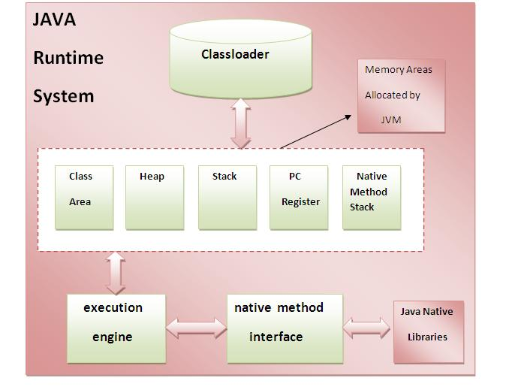

### 1) Classloader:

Classloader is a subsystem of JVM that is used to load class files.

### 2) Class(Method) Area:

Class(Method) Area stores per-class structures such as the runtime constant pool, field and method data, the code for methods.

### 3) Heap:

It is the runtime data area in which objects are allocated.

### 4) Stack:

|  |
| --- |
| Java Stack stores frames.It holds local variables and partial results, and plays a part in method invocation and return. |
| Each thread has a private JVM stack, created at the same time as thread. |
| A new frame is created each time a method is invoked. A frame is destroyed when its method invocation completes. |

### 5) Program Counter Regiser:

PC (program counter) register. It contains the address of the Java virtual machine instruction currently being executed.

### 6) Native Method Stack:

It contains all the native methods used in the application.

### 7) Execution Engine:

|  |
| --- |
| It contains: |
| **1) A virtual processor** |
| **2) Interpreter:**Read bytecode stream then execute the instructions. |
| **3) Just-In-Time(JIT) compiler:**It is used to improve the performance.JIT compiles parts of the byte code that have similar functionality at the same time, and hence reduces the amount of time needed for compilation.Here the term ?compiler? refers to a translator from the instruction set of a Java virtual machine (JVM) to the instruction set of a specific CPU. |

# 1.9. Variable and Datatype in Java

|  |
| --- |
| In this page, we will learn about the variable and java data types. Variable is a name of memory location. There are three types of variables: local, instance and static. There are two types of datatypes in java, primitive and non-primitive. |

### Variable

|  |
| --- |
| Variable is name of reserved area allocated in memory. |
| variable in java |

int data=50;//Here data is variable

## 1.9.1.Types of Variable

|  |
| --- |
| There are three types of variables in java   * local variable * instance variable * static variable |

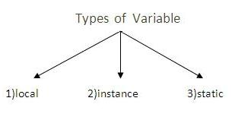

#### Local Variable

|  |
| --- |
| A variable that is declared inside the method is called local variable. |

#### Instance Variable

|  |
| --- |
| A variable that is declared inside the class but outside the method is called instance variable . It is not declared as static. |

#### Static variable

|  |  |
| --- | --- |
| A variable that is declared as static is called static variable. It cannot be local. | |
| We will have detailed learning of these variables in next chapters. |

#### Example to understand the types of variables

class A{

int data=50;//instance variable

static int m=100;//static variable

void method(){

int n=90;//local variable

}

}//end of class

# 1.10. Data Types in Java

|  |
| --- |
| In java, there are two types of data types   * primitive data types * non-primitive data types |

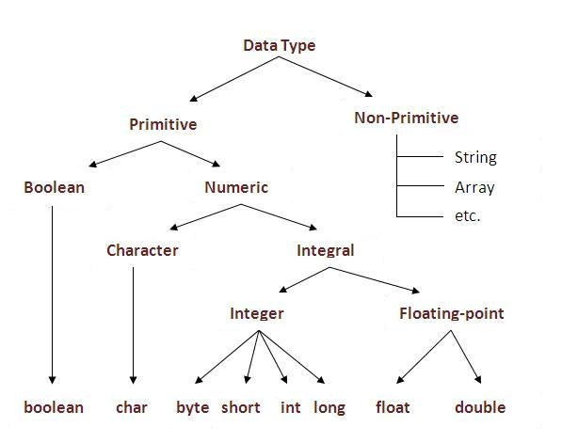

|  |  |  |
| --- | --- | --- |
| **Data Type** | **Default Value** | **Default size** |
| boolean | false | 1 bit |
| char | '\u0000' | 2 byte |
| byte | 0 | 1 byte |
| short | 0 | 2 byte |
| int | 0 | 4 byte |
| long | 0L | 8 byte |
| float | 0.0f | 4 byte |
| double | 0.0d | 8 byte |

### Why char uses 2 byte in java and what is \u0000 ?

|  |
| --- |
| because java uses unicode system rather than ASCII code system. \u0000 is the lowest range of unicode system.To get detail about Unicode see below. |

# 1.11. Operators in java

**Operator** is a special symbol that is used to perform operations. There are many types of operators in java such as unary operator, arithmetic operator, relational operator, shift operator, bitwise operator, ternary operator and assignment operator.

|  |  |
| --- | --- |
| **Precedence of Operators** | |
| **Operators** | **Precedence** |
| postfix | expr++ expr-- |
| unary | ++expr --expr +expr -expr ~ ! |
| multiplicative | \* / % |
| additive | + - |
| shift | << >> >>> |
| relational | < > <= >= instanceof |
| equality | == != |
| bitwise AND | & |
| bitwise exclusive OR | ^ |
| bitwise inclusive OR | | |
| logical AND | && |
| logical OR | || |
| ternary | ? : |
| assignment | = += -= \*= /= %= &= ^= |= <<= >>= >>>= |